**WHAT IS AI**



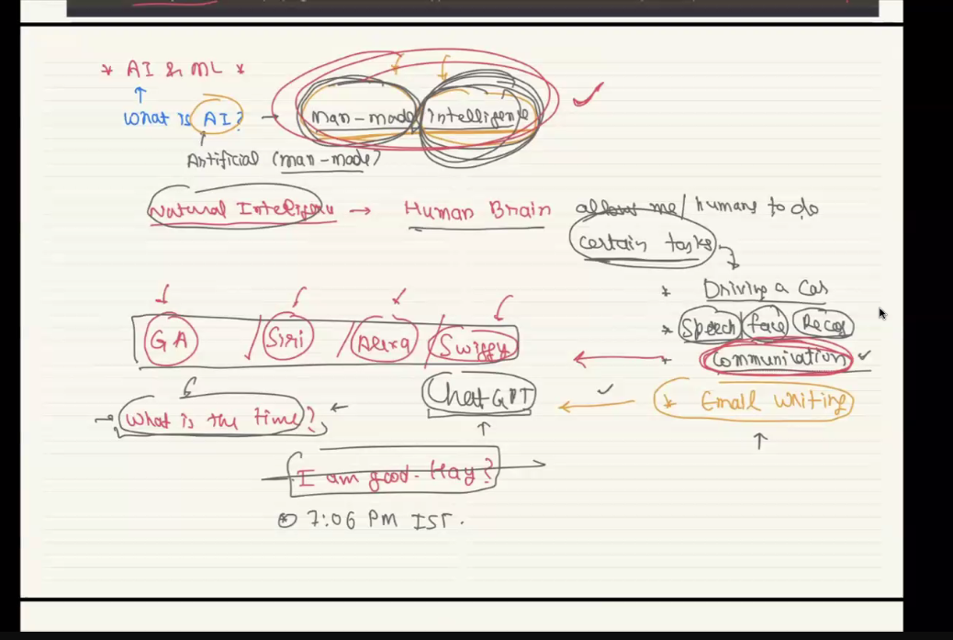

**WHAT IS NATRUAL INTELLIGENECE TASK**

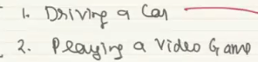

**WHAT IS ML?**

It is process of training machines jThis is the methods that helps too develop AI human like model.

It has three method

1. Supervised
2. Unsupervised
3. Reinforcement

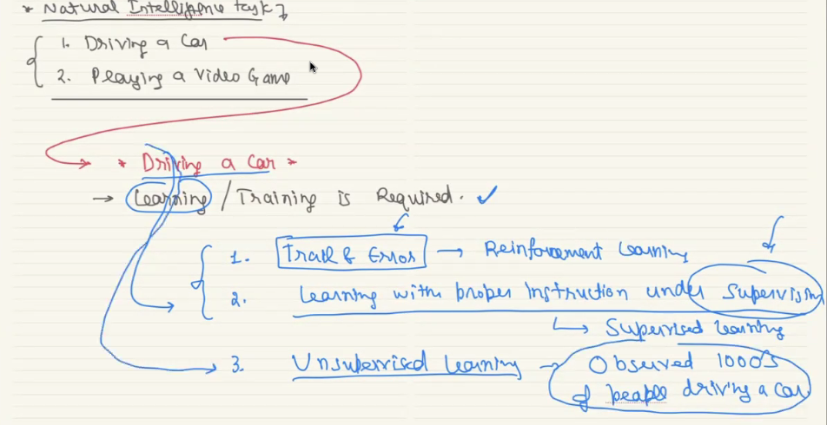

Candel stick plot on stock market open and close is the time f stock market timing of open and clode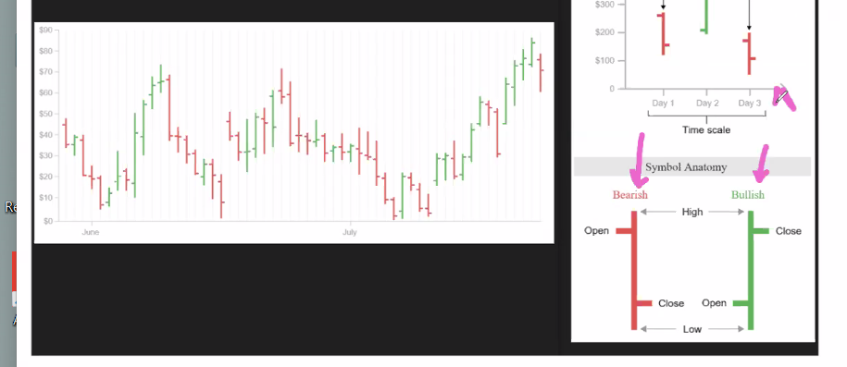

In second question we want to predict house price so it is unsupervised learning, the target label is house price prediction, but in data have only the house details like below

